# Wilken Property services



# Modules and Features

1. Registration
   1. New clients, tenants, users, Properties, estates
2. Reports
   1. Financial, master cash etc.
3. Dashboard
   1. Day to day requests and Inquiries.
   2. Expiry dates
4. Properties/Estates
5. Tenants
6. Rooms/units
7. Security Deposits
8. Expenses (Repairs)
9. Reports
10. Banking /Accounts Utilities
11. Damages and Evictions
12. Activity logs

# Access Control/Login

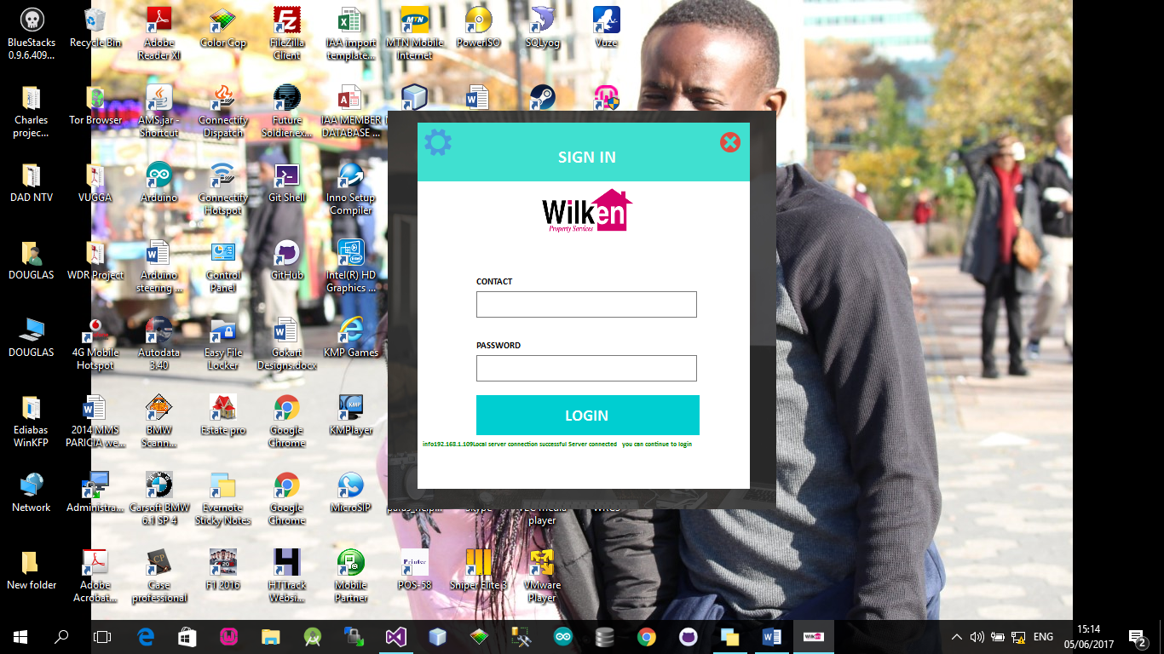

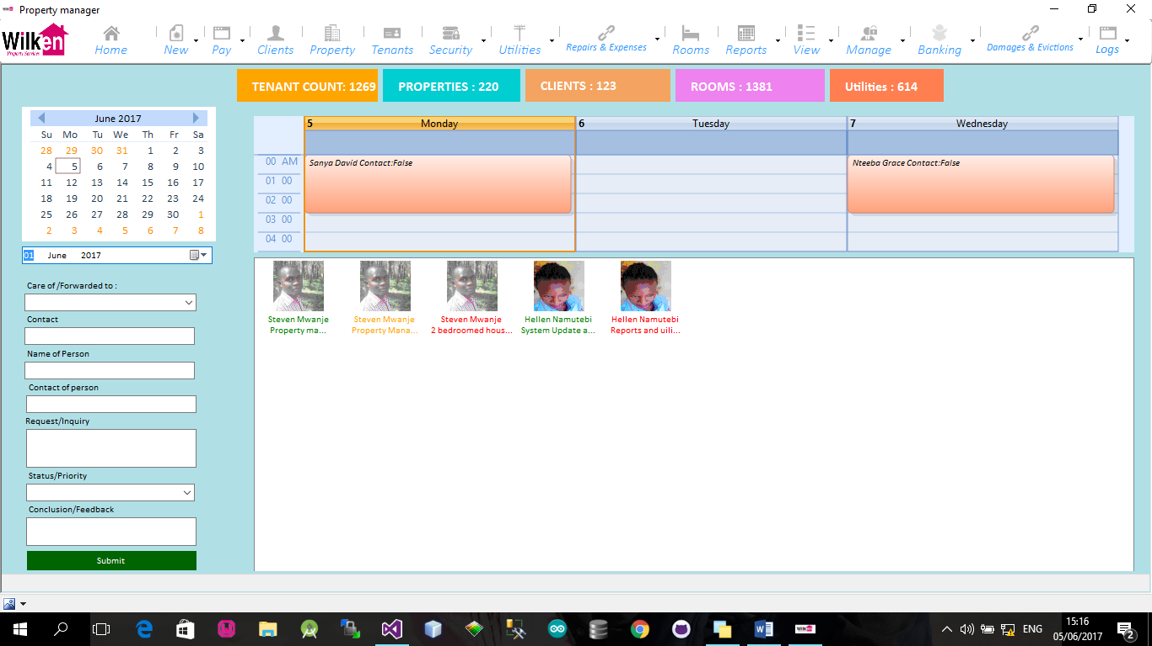

# Registration

Tenant and Room/Apartment Registration

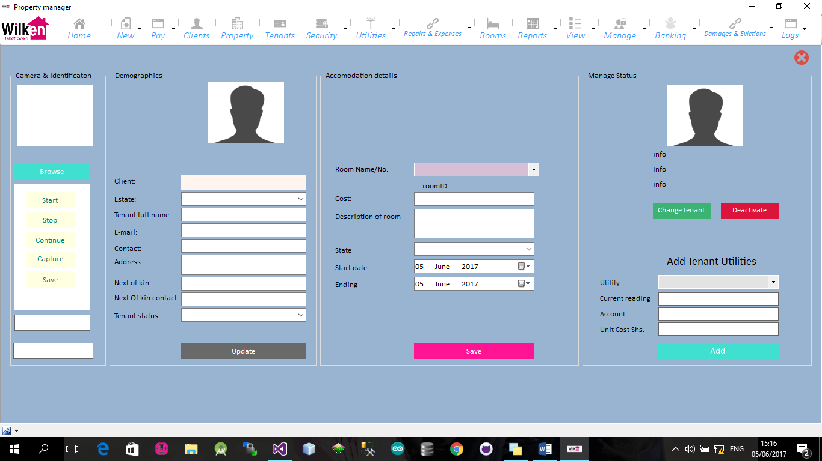

Client Registration

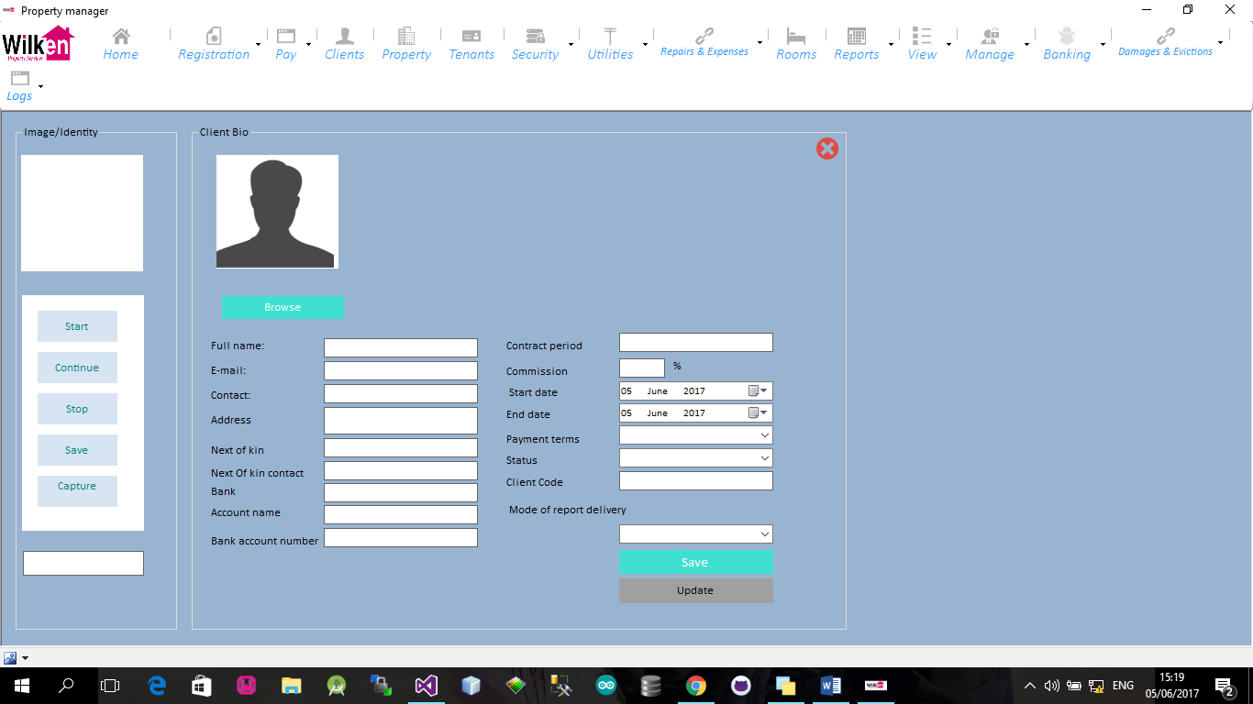

Property Registration

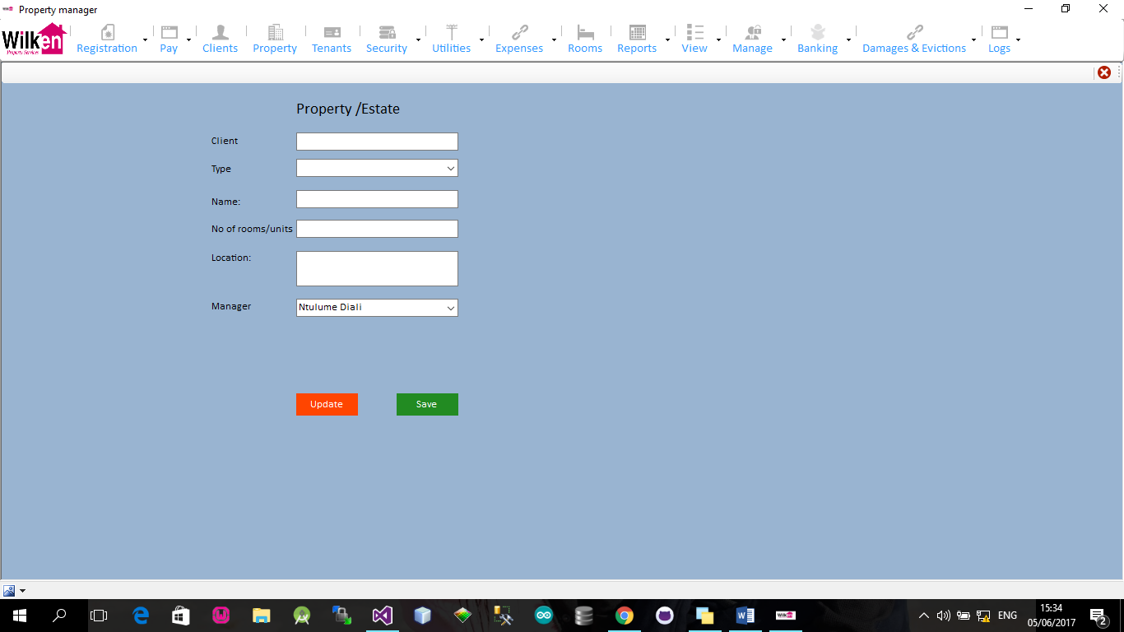

# Rooms/units

# Users

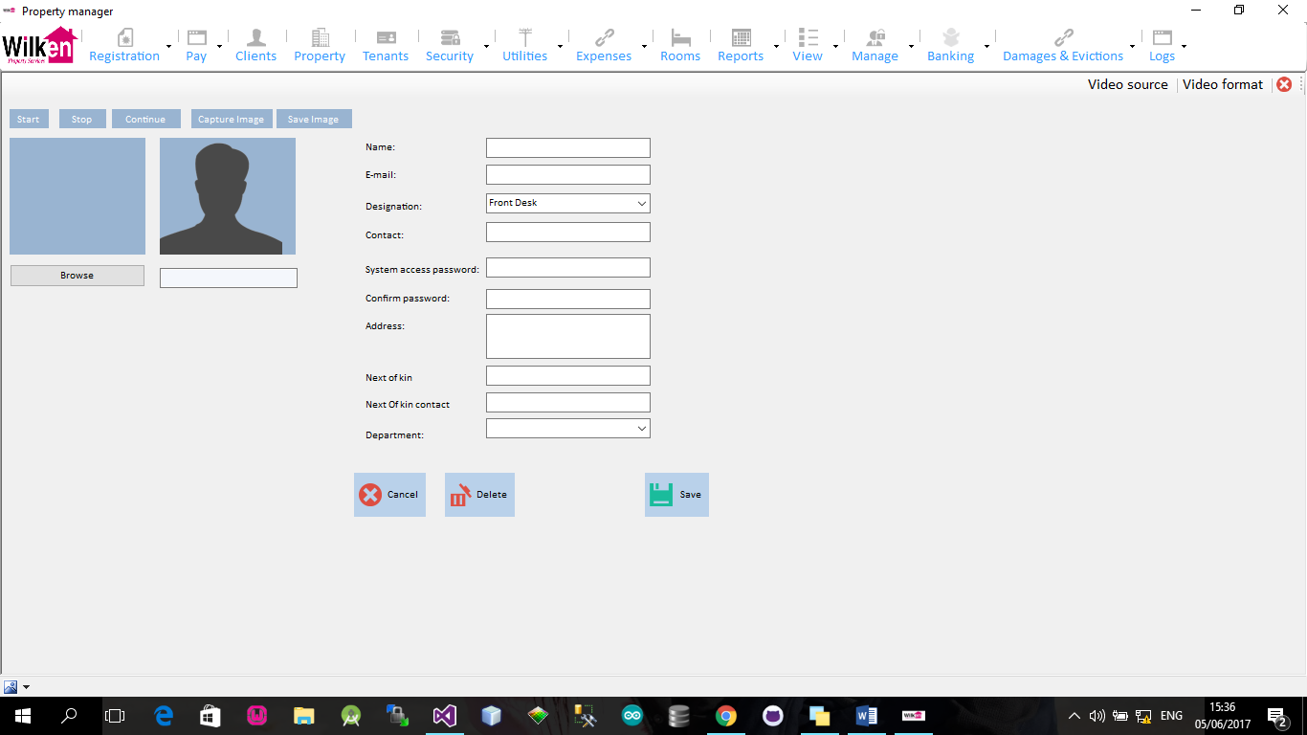

# Client Modules

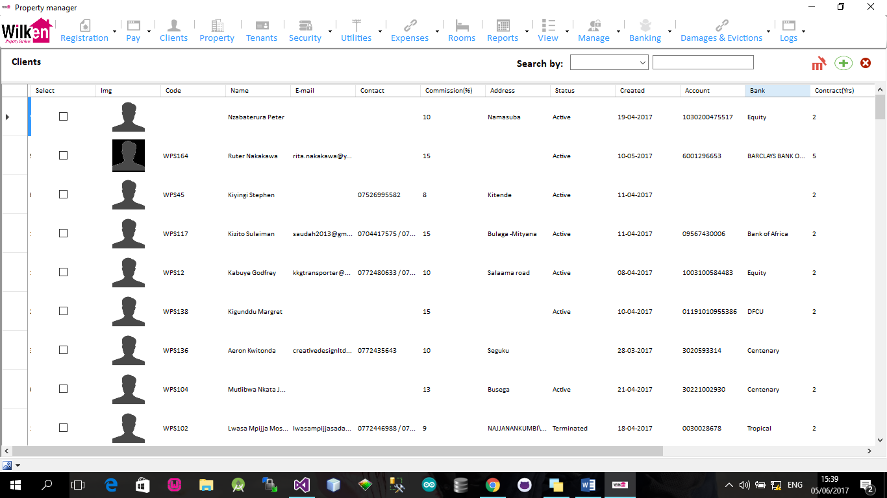

# Tenants Module

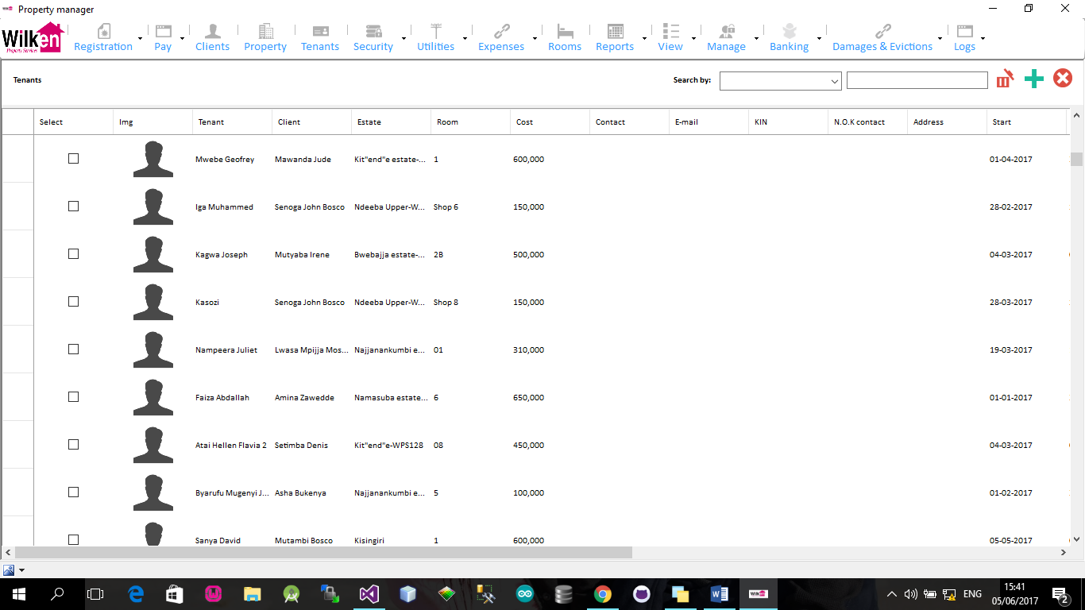

# Properties

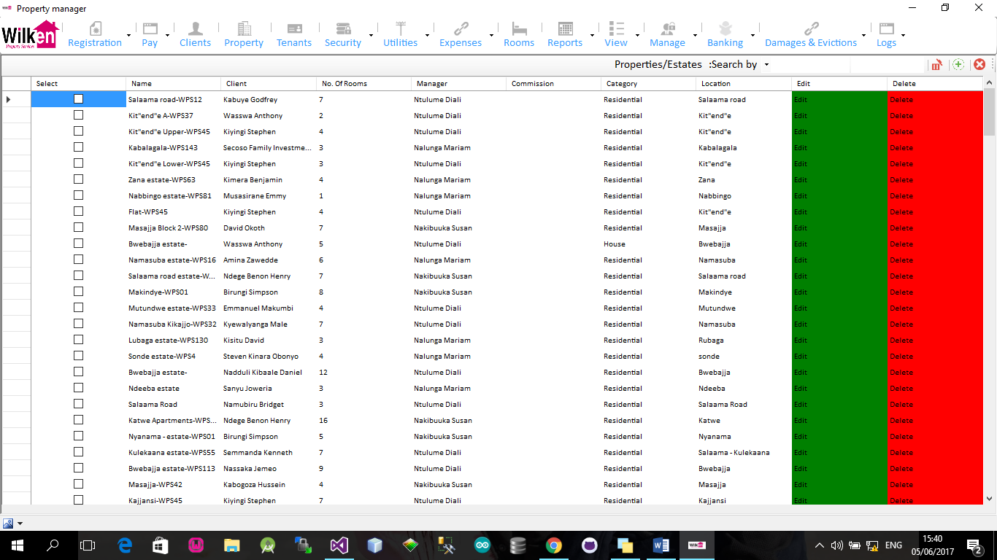

# Security Deposit management

1. Payment

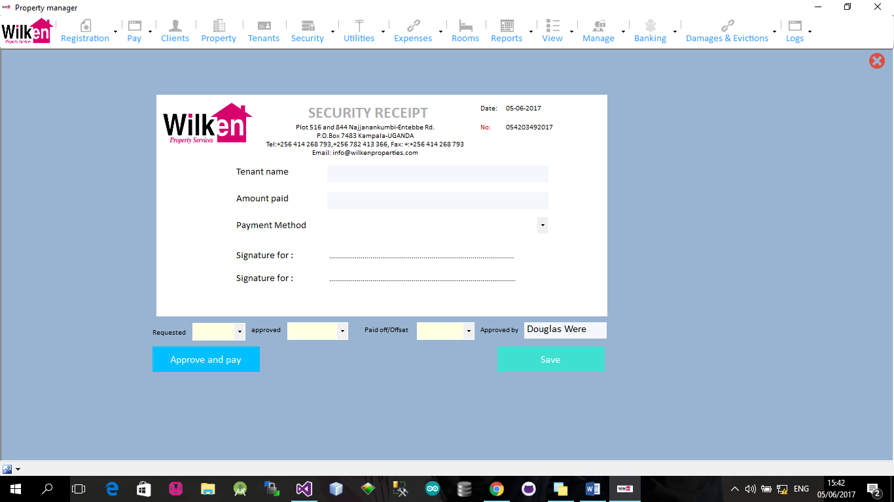

2. View

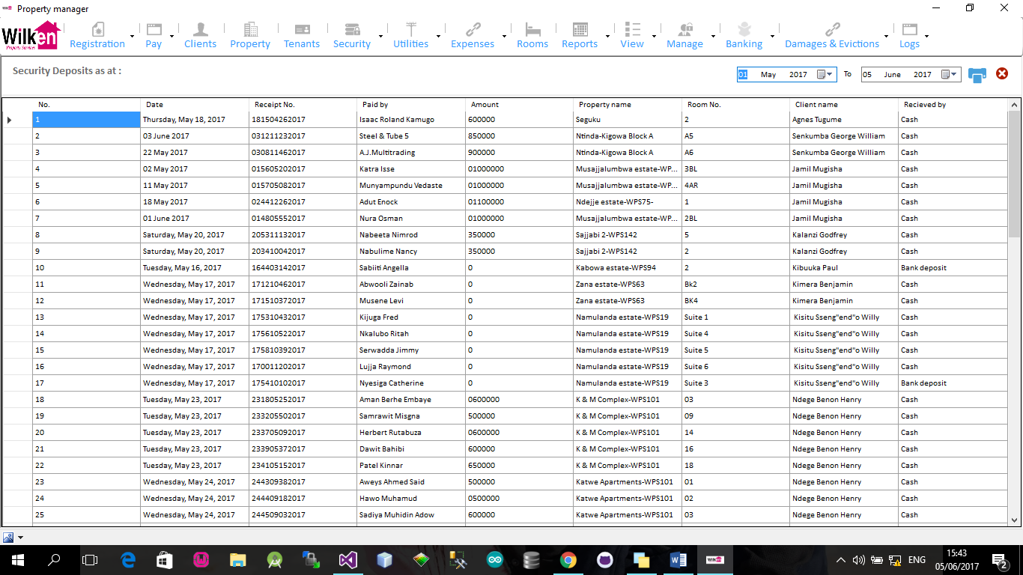

3. Security Requisitions

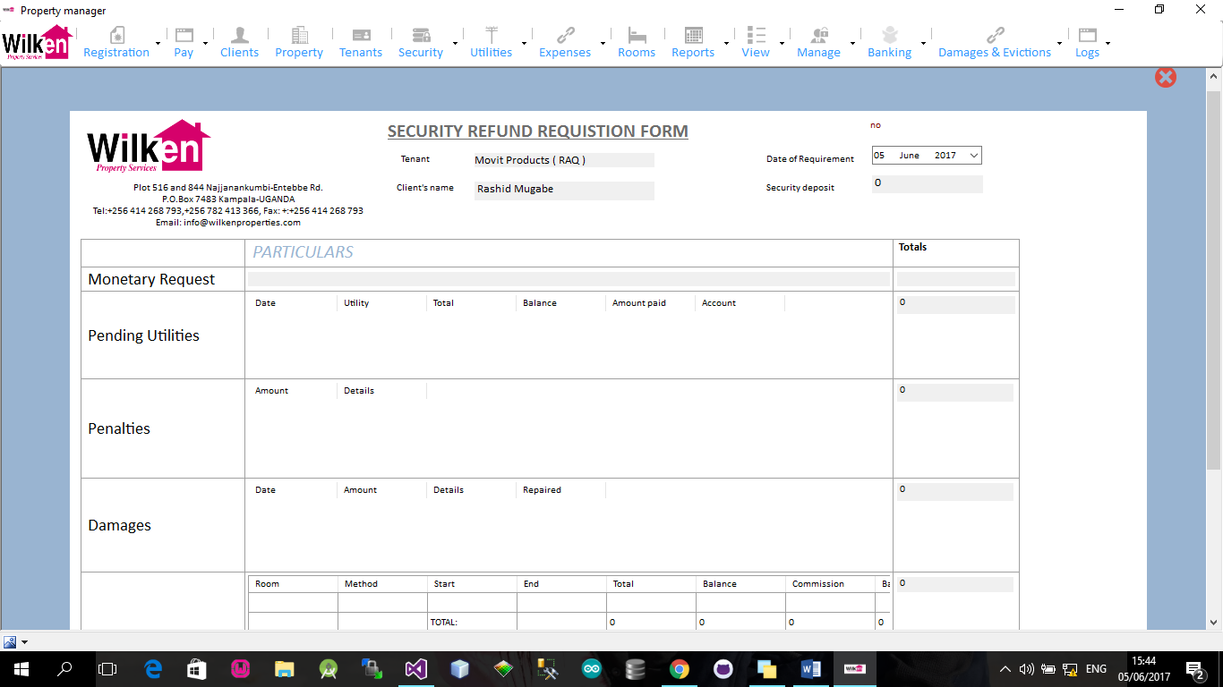

# Utilities

Registration

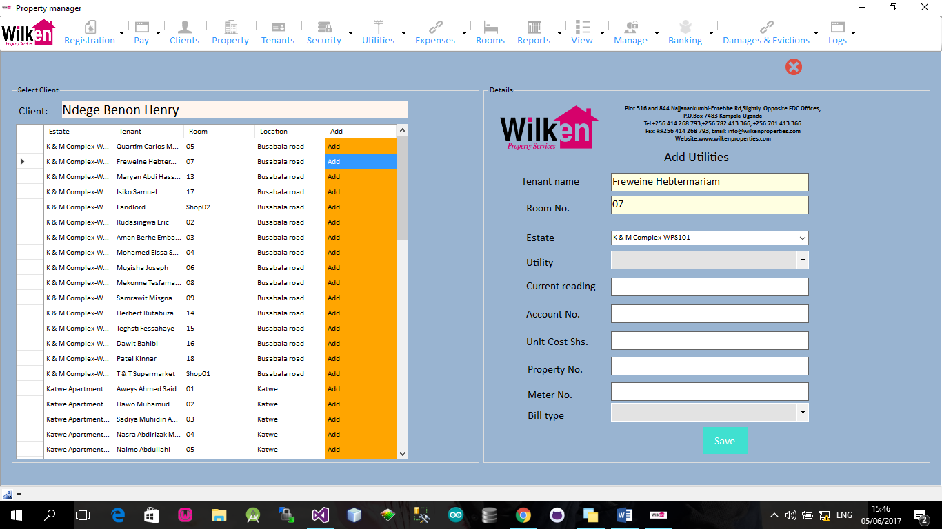

Reminders

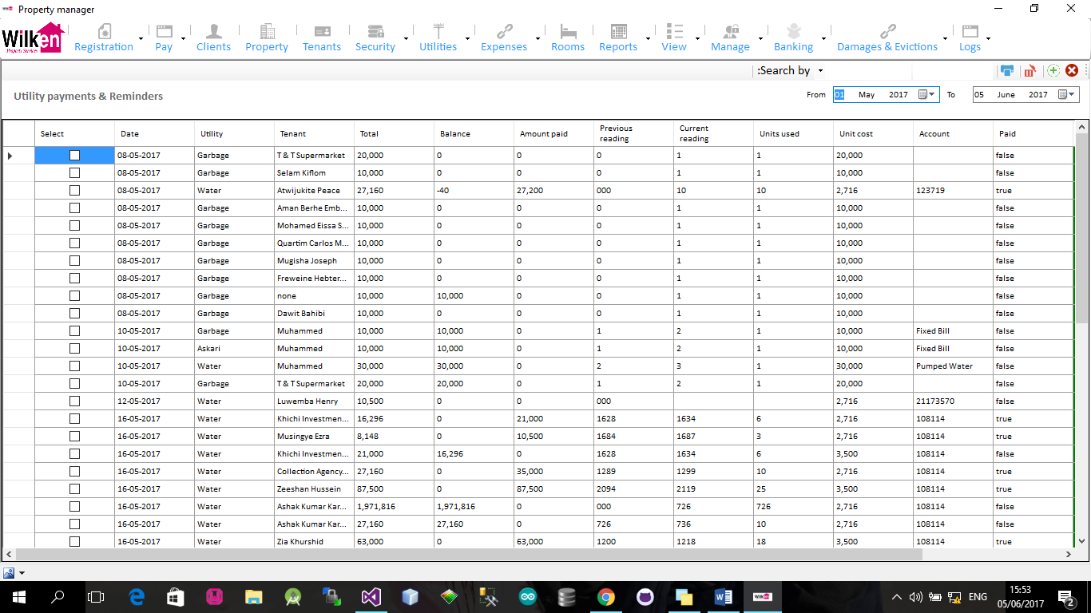

Payment & reminders

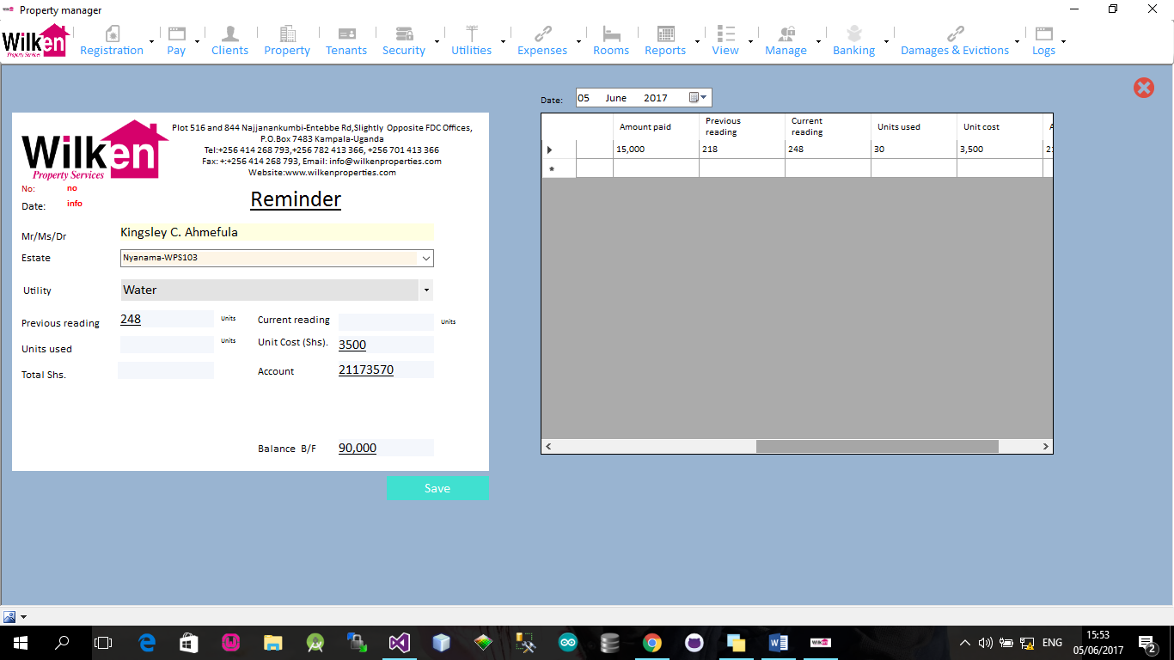

Utility and tenant modules

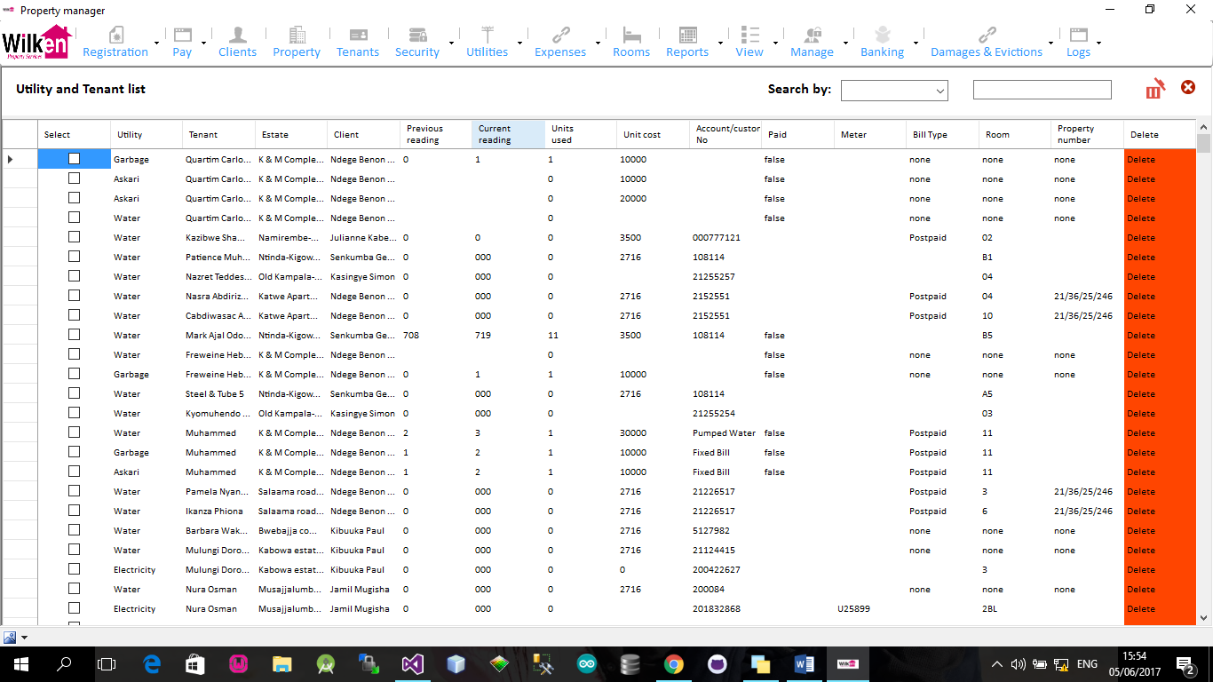

# Expenses

New Repair Declaration

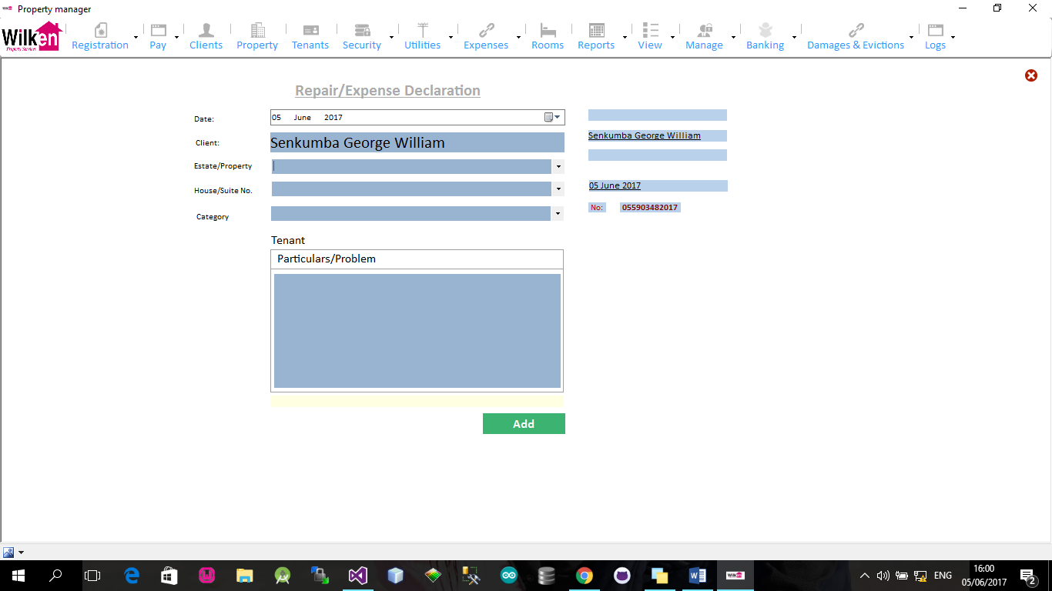

List of damages and repairs

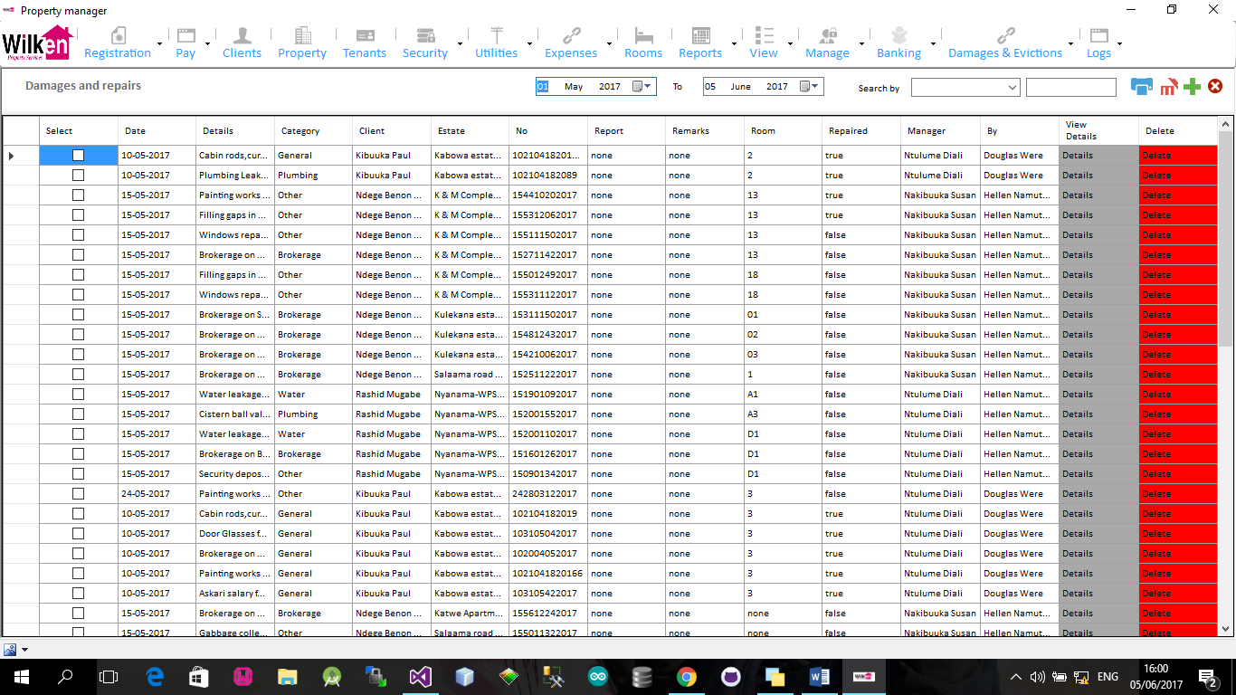

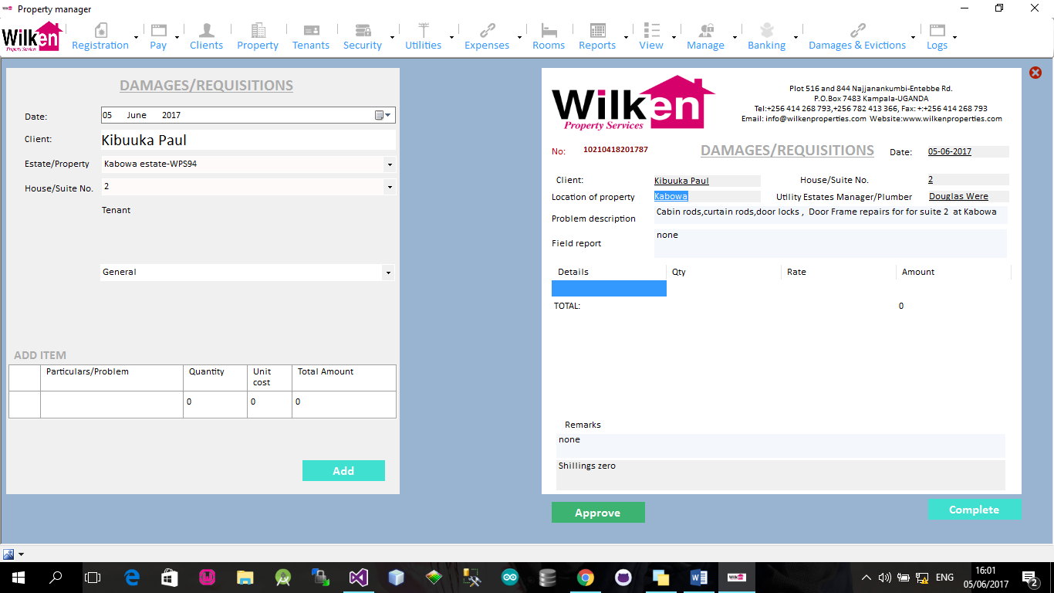Expense Requisition based on declaration

Expenses (Approved and pending)

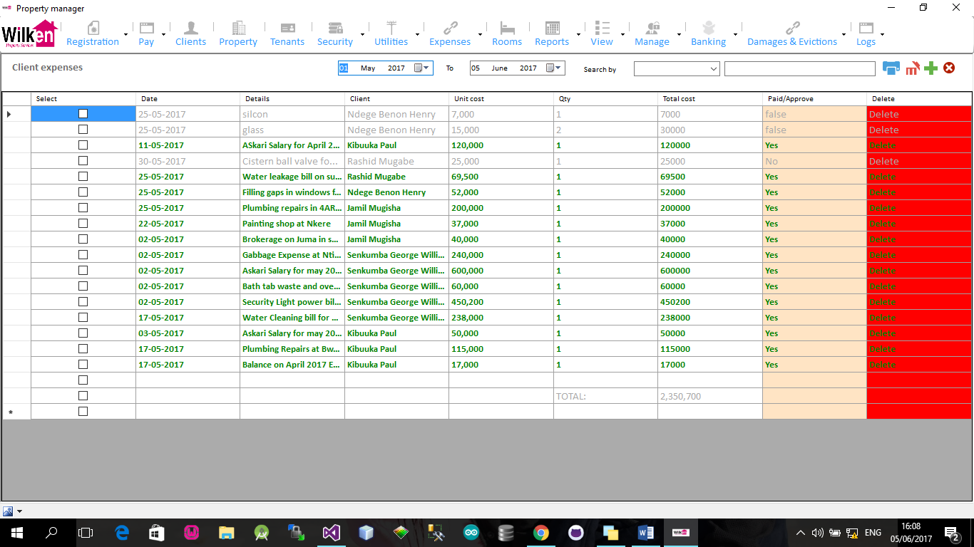

# Reports

Financial Reports

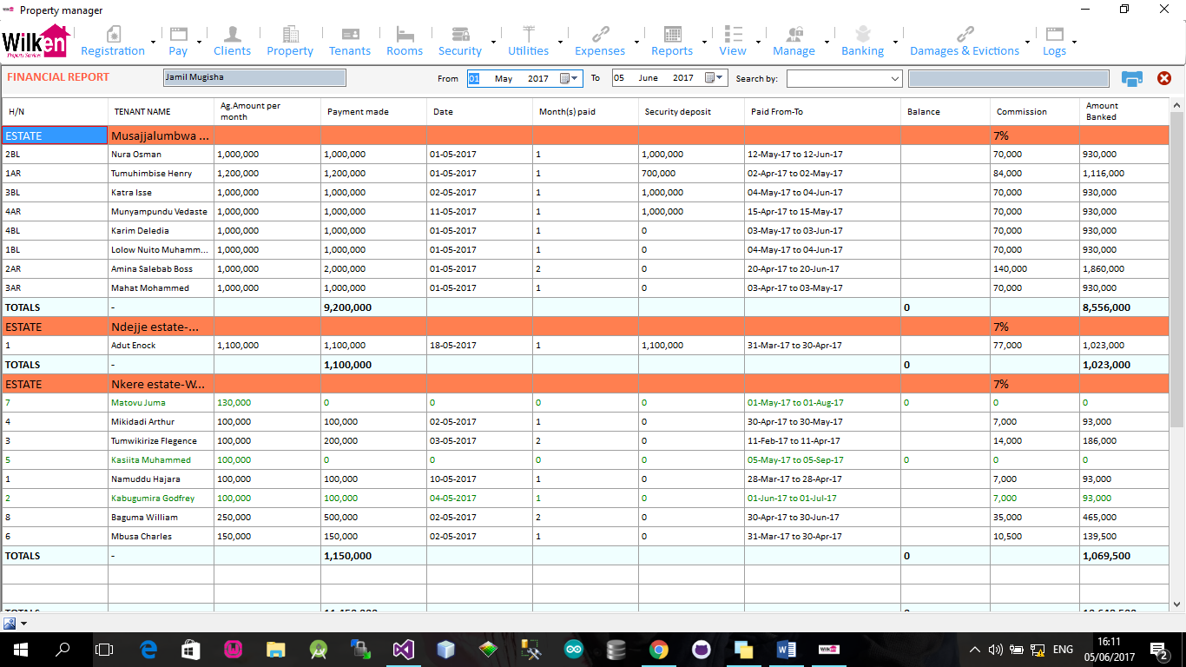

1. Daily collection
2. Client Rental Collection
3. Expense Report
4. Expense Summary
5. Master Cash Register
6. Utility Report
7. General utility Report
8. Rental Collection & Expenses
9. Rental Collection Summary

# Other Reports

1. Rent Receipts
2. Banking
3. Expenses
4. Instalments
5. Utility Payments & Reminders
6. Security Requisitions
7. Cash Receipts
8. Tenant Ledger
9. Rent collection Summary
10. Deduction Report
11. Outstanding Balance
12. Amount Banked
13. Client Report Delivery
14. Application Settings
15. Users
16. User roles

# Banking

Banking Requisition

# Damages and Evictions

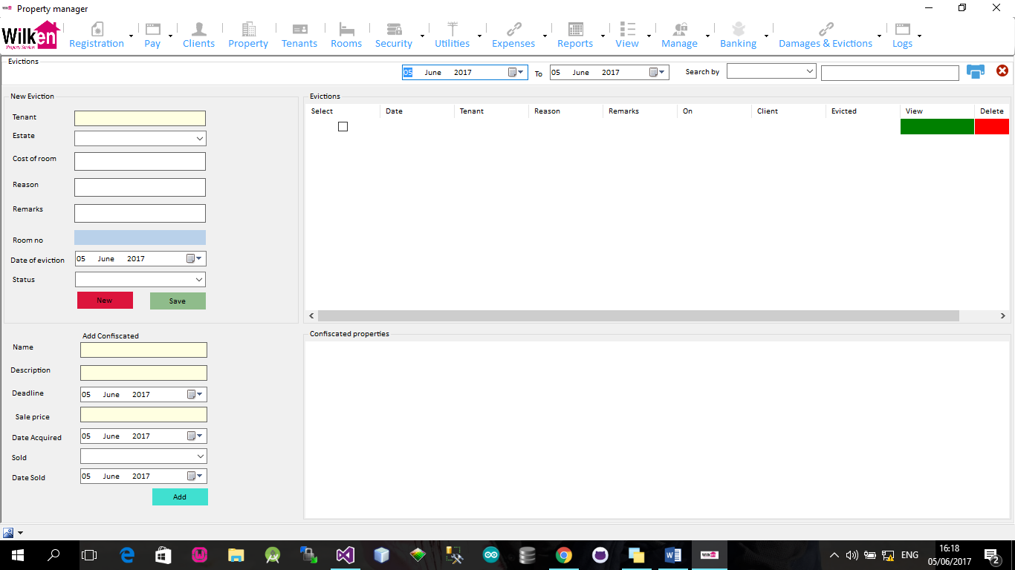

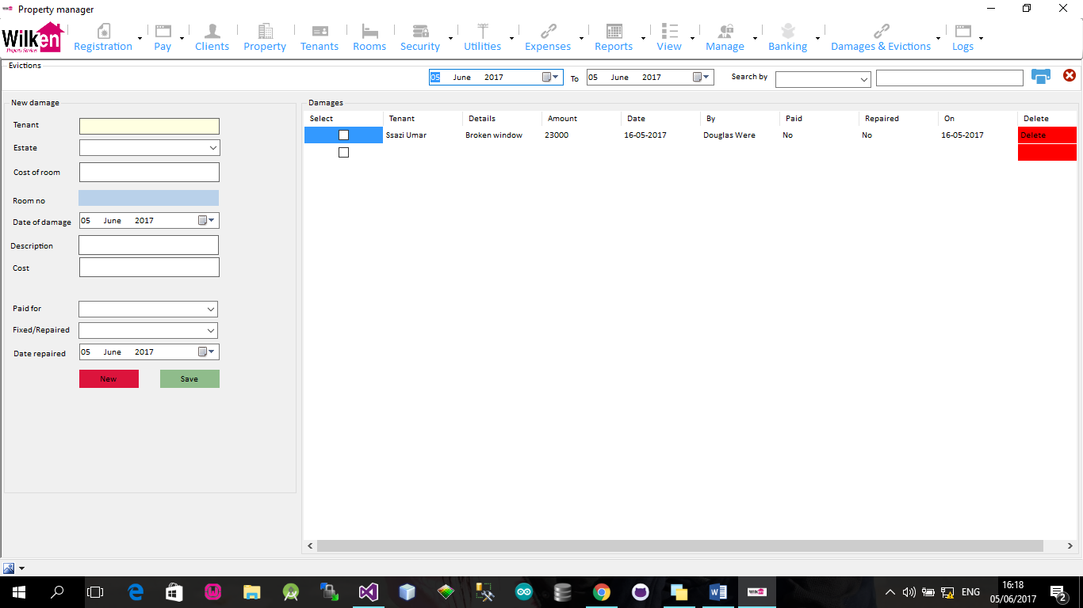

# Activity Logs and error capturing

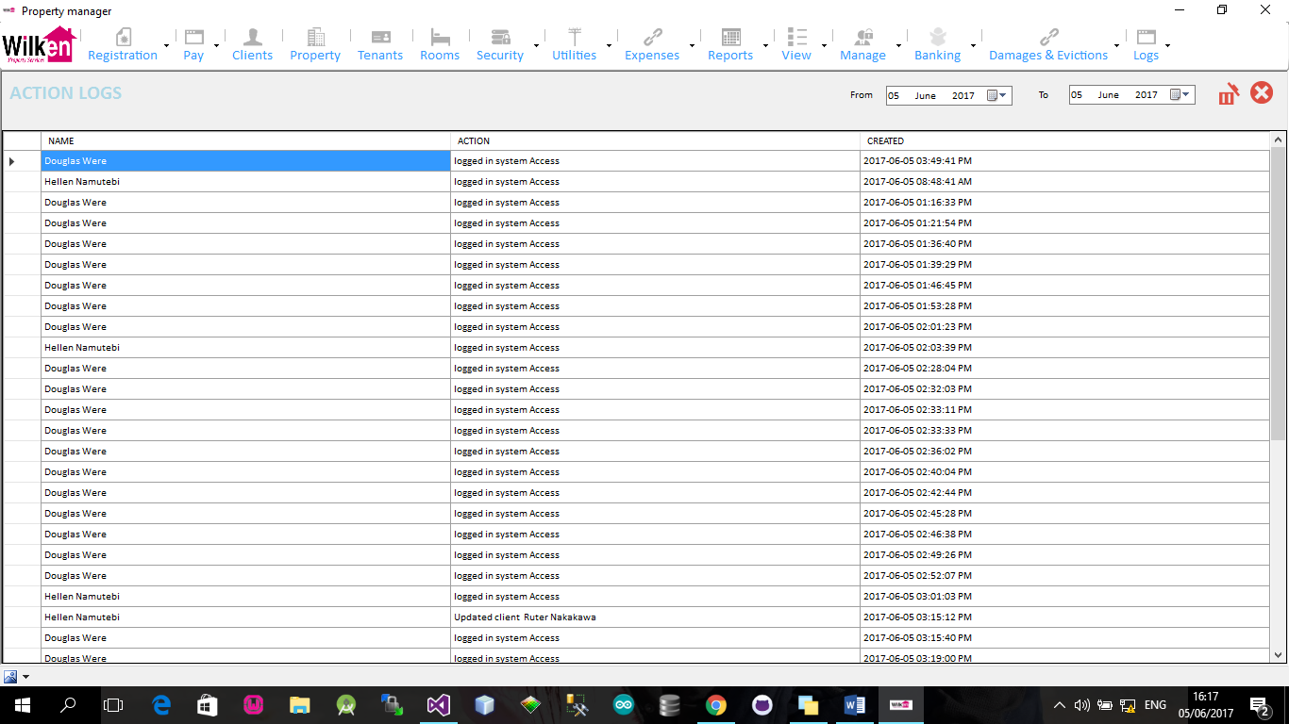

# Required additional Reports and Required Features

1. Types of rooms /units i.e apartment, house.

2. Property Visitation Form

3. Client EFT account

4. Estate manage score card

5. Utility Master File Record

6. General Utility payment Report

7. Reported Repairs

8. Utility Records

9. Approved client Expenses

10. Client Periodic Statements

11. House Checklist

12. Estate allocation per manager

13. Data Exports to Excel and other formats

# Future Features

* H/R modules
* Leave /Birthdays
* Logging in time of checking and out
* Land sales
* Add longitude and latitude mapping
* Internal company expenses

# Proposed online system Development and estate management software as a service

# Advantages and features

* Remote access to all EPR information
* Client online Report access
* Automatic sms reminders for utilities and rent overdue
* Generic report Generation
* Tenant Complaints and real time logging
* Internal communication and responsiveness by staff this will greatly improve relationships between Wilken ,the clients and their respective tenants
* Remote access by probable new tenants to the available rooms and estates i.e properties and land for sale thru online portal (An API can be generated to connect to the online website showing real time states)
* SMS services providing real time information about current rental searches and complaint status
* Automated email services for reports to the clients and other concerned parties
* Well predefined data back up

# 

# 

# Continued Development

|  |  |  |  |  |
| --- | --- | --- | --- | --- |
| **Module** | **Assumptions** |  | **Costs(UGX)** | **Supplementary modules** |
| **1.Additional Module development** | Estimated time is 2 months |  | 1,500,000/= |  |
| **2.UX and UI** |  |  | 500,000/= |  |
| **Miscellaneous** | Transport, airtime ,internet etc. |  | 10%(total cost) |  |
|  |  | **TOTAL** | **2,200,000/=** |  |

# Online application development (documented in the ERP system above)

|  |  |  |  |  |
| --- | --- | --- | --- | --- |
| **Module** | **Assumptions** |  | **Costs(UGX)** | **Supplementary modules** |
| **1.System design and architecture** |  |  | 1,400,000/=( 2 months) |  |
|  |  |  |  |  |
| **2.UX and UI** |  |  | 500,000/= |  |
| 3.ERP data synchronisation to Online database server | Data structure and entities well defined in the ERP application |  | 500,000/= |  |
|  |  |  |  |  |
| **4.Database development and design** |  |  | 600,000/= |  |
| **5.Testing** |  |  | 200,000/= |  |
|  |  |  |  |  |
| **Miscellaneous** | Transport, airtime ,internet etc. |  | 10%(total cost) |  |
|  | **TOTAL** |  | **3,320,000/=** |  |
| FEATURES (Optional) | | | | |
| **Mobile Money Payment Integration for registration** |  |  |  |  |
| **Reporting modules** | (Highly Dependent on the Agreed data to be collected) |  |  |  |
|  | **SUB TOTAL** |  |  |  |
|  |  |  |  |  |
|  |  |  |  |  |

# TIME LINES

|  |  |  |  |  |  |  |  |  |
| --- | --- | --- | --- | --- | --- | --- | --- | --- |
|  | **Week 1** | **Week 2** | **Week 3** | **Week 4** | **Week 5** | **Week 6** | **Week 7** | **Week 8** |
| System architecture and design |  |  |  |  |  |  |  |  |
| System mock up |  |  |  |  |  |  |  |  |
| Database design |  |  |  |  |  |  |  |  |
| System and application programming |  |  |  |  |  |  |  |  |
| System debugging |  |  |  |  |  |  |  |  |
| System testing |  |  |  |  |  |  |  |  |

# System architecture and Design

Legal

Accounts

Estates

**Front Desk /Reception**

Marketing

Utilities

Server

DBMS postgres/database

Data synchronisation

* Complaints
* Incoming Message

Azure, Amazon

Google and shared subdomain server

Cloud DBMS

* API
* ISP
* SMS providers

Web Dashboard (Online Application interface)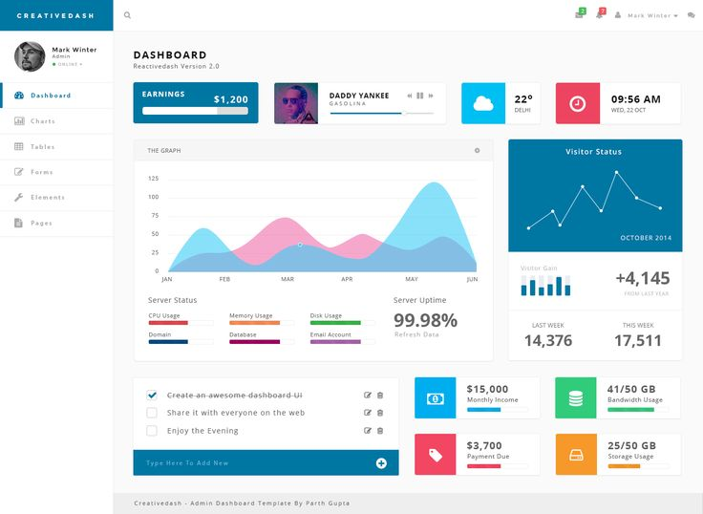

* Online reports
* And applicable features
* Graphical Reports
* APIs Interfaces

Mobile application 

# Software as a service Proposal

|  |  |  |  |
| --- | --- | --- | --- |
| **Module** | **Assumptions** | **Costs(UGX)** | **Supplementary modules** |
| **Online system Design maintenance and services** | Tenant payments to Wilken property services | 600/= |  |
| **2.Service Cost** |  |  |  |
|  | **Sms Services** | FREE |  |
| **3.System Maintenance** | Email costs | FREE |  |
| **4.Online reports** | Graphical and tabular | FREE |  |
| **5.API Integrations** | @ API | 500,000/= |  |
|  |  |  |  |
|  |  |  |  |
|  | TOTAL | Will depend on usage |  |

# Maintenance cost

|  |  |  |
| --- | --- | --- |
| **Module** | **Assumptions** | **Costs(UGX)** |
| **1.Requirement specifications and reimplementation** | Based on modular requirements | 100,000/= |
| **2.ERP system updates and upgrades** | Modular and requirements specification per module | 100,000/= |
| **3.Database migration** | Modular | 500,000/= |
|  | TOTAL | Will depend on usage |

# Areas of concern

1. Data backups from the ERP